Corporate Finance, (Berk/DeMarzo)
Chapter 30 Risk Management

30.1 Insurance

Use the following information to answer the question(s) below.

Rearden Metal imports ore from South America. Rearden Metal is worried that the South American mines may enter into a long-term contract with the Chinese to sell all of their ore output to China, hence cutting off Rearden Metal's supply. In the event of such a contract with the Chinese, Rearden Metal will face much higher costs for its raw materials causing its operating profits to decline substantially and its marginal tax rate to fall from its current level of 35% down to 10%. An insurance firm has agreed to write a trade insurance policy that will pay Rearden Metal $2,500,000 in the event of the South American supply of ore being cut off. The chance of the South American supply being cut off is estimated to be 20%, with a beta of -2.0. The risk-free rate of interest is 4% and the return on the market is estimated to be 12%.

1) The actuarially fair premium for this insurance policy is closest to:
A) $417,000
B) $446,000
C) $500,000
D) $568,000
Answer: D
Explanation: D) rL = rf + βL(rm - rf) = 4% + (-2.0)(12% - 4%) = -12%
Insurance Premium = 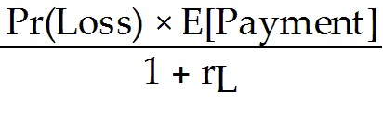 = 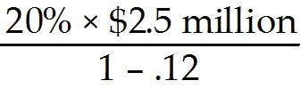 = $568,000
Diff: 2
Section: 30.1 Insurance
Skill: Analytical

2) Rearden's NPV for purchasing this policy is closest to:
A) $32,500
B) $56,750
C) $142,000
D) $156,250
Answer: C
Explanation: C) rL = rf + βL(rm - rf) = 4% + (-2.0)(12% - 4%) = -12%

Insurance Premium = 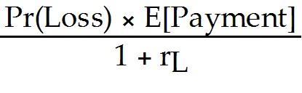 = 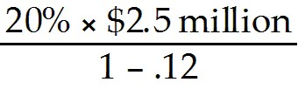 = $568,000
NPV = -Premium(1 - Thigh) + 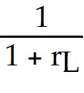 × Pr(Loss) × Payment × (1 - Tlow)
= -568,182(1 - .35) + 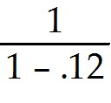(.20)($2,500,000)(1 - .10) = $142,045
Diff: 3
Section: 30.1 Insurance
Skill: Analytical
3) To insure their assets against hazards such as fire, storm damage, vandalism, earthquakes, and other natural and environmental risks firms commonly purchase:
A) key personnel insurance.
B) business liability insurance.
C) business interruption insurance.
D) property insurance.
Answer: D
Diff: 1
Section: 30.1 Insurance
Skill: Definition

4) To cover the costs that result if some aspect of the business causes harm to a third party or someone else's property a firm would purchase:
A) business interruption insurance.
B) property insurance.
C) business liability insurance.
D) key personnel insurance.
Answer: C
Diff: 1
Section: 30.1 Insurance
Skill: Definition

5) To protect the firm against the loss of earnings if the business operations are disrupted due to fire, accident, or some other insured peril a firm would purchase:
A) property insurance.
B) key personnel insurance.
C) business liability insurance.
D) business interruption insurance.
Answer: D
Diff: 1
Section: 30.1 Insurance
Skill: Definition

6) Insurance that compensates for the loss or unavoidable absence of crucial employees in the firm is called:
A) key personnel insurance.
B) business liability insurance.
C) property insurance.
D) business interruption insurance.
Answer: A
Diff: 1
Section: 30.1 Insurance
Skill: Definition
7) In reality market imperfections exist that can raise the cost of insurance above the actuarially fair price and offset some of these benefits. These insurance market imperfections include all of the following EXCEPT:
A) adverse selection.
B) agency costs.
C) administrative and overhead costs.
D) taxation of insurance payments.
Answer: D
Diff: 2
Section: 30.1 Insurance
Skill: Conceptual

8) Which of the following statements is FALSE?
A) Not all insurable risks have a beta of zero. Some risks, such as hurricanes and earthquakes, create losses of tens of billions of dollars and may be difficult to diversify completely.
B) When a firm buys insurance, it transfers the risk of the loss to an insurance company. The insurance company charges an upfront premium to take on that risk.
C) By its very nature, insurance for non-diversifiable hazards is generally a positive beta asset; the insurance payment to the firm tends to be larger when total losses are low and the market portfolio is high.
D) Because insurance provides cash to the firm to offset losses, it can reduce the firm's need for external capital and thus reduce issuance costs.
Answer: C
Explanation: C) By its very nature, insurance for non-diversifiable hazards is generally a negative beta asset (it pays off in bad times); the insurance payment to the firm tends to be larger when total losses are high and the market portfolio is low.
Diff: 2
Section: 30.1 Insurance
Skill: Conceptual

9) Which of the following statements is FALSE?
A) Because insurance reduces the risk of financial distress, it can relax this tradeoff and allow the firm to increase its use of debt financing.
B) By lowering the volatility of the stock, insurance discourage concentrated ownership by an outside director or investor who will monitor the firm and its management.
C) When a firm is subject to graduated income tax rates, insurance can produce a tax savings if the firm is in a higher tax bracket when it pays the premium than the tax bracket it is in when it receives the insurance payment in the event of a loss.
D) In a perfect market without other frictions, insurance companies should compete until they are just earning a fair return and the NPV from selling insurance is zero. The NPV is zero if the price of insurance equals the present value of the expected payment; in that case, we say the price is actuarially fair.
Answer: B
Explanation: B) By lowering the volatility of the stock, insurance can encourage concentrated ownership by an outside director or investor who will monitor the firm and its management.
Diff: 2
Section: 30.1 Insurance
Skill: Conceptual
Use the information for the question(s) below.

Your firm faces an 8% chance of a potential loss of $50 million next year. If your firm implements new safety policies, it can reduce the chance of this loss to 3%, but the new safety policies have an upfront cost of $250,000. Suppose that the beta of the loss is 0 and the risk-free rate of interest is 5%.

10) If your firm is uninsured, the NPV of implementing the new safety policies is closest to:
A) $2.25 million
B) -$.25 million
C) $2.5 million
D) $2.15 million
Answer: D
Explanation: D) Expected loss without new safety policies = .08 × $50 million = $4 million
Expected loss with new safety policies = .03 × $50 million = $1.5 million

Expected gain from safety program = $4 million - $1.5 million = $2.5 million

NPV = -250,000 + 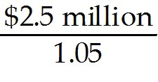 = $2,130,952
Diff: 2
Section: 30.1 Insurance
Skill: Analytical

11) If your firm is fully insured, the NPV of implementing the new safety policies is closest to:
A) $2.15 million
B) $2.5 million
C) $2.25 million
D) -$.25 million
Answer: D
Explanation: D) If the firm is fully insured, the insurance company will pay for the loss regardless if whether the safety program is in force or not. Therefore, the end of period cash flows will be identical with or without the program and the NPV is -$250,000 reflecting the cost of the safety program.
Diff: 2
Section: 30.1 Insurance
Skill: Analytical

12) What is the actuarially fair cost of full insurance?
Answer: Insurance Premium = 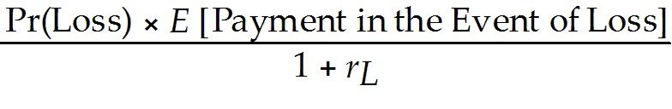
The actuarially fair cost of full insurance = 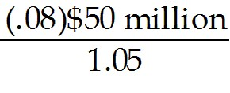 = $3.81 million
Diff: 1
Section: 30.1 Insurance
Skill: Analytical
13) Assuming that your firm will purchase insurance, what is the minimum-size deductible that would leave your firm with an incentive to implement the new safety policies?
Answer: If the firm is fully insured (no deductible), the insurance company will pay for the loss regardless if whether the safety program is in force or not. Therefore, the end of period cash flows will be identical with or without the program and the NPV is -$250,000 reflecting the cost of the safety program.

In order to give the firm the incentive to buy the insurance the NPV of the safety program must be positive.

Another way of looking at this is to find the point where the PV of the expected deductible equals the cost of the safety program. Mathematically we have:
(.08 - .03)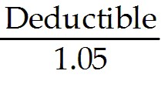 = $250,000, solving for the Deductible = 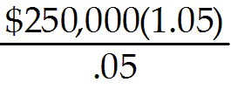 = $5,250,000

To show that this indeed is the correct answer:
(.08)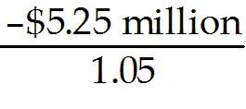 = (.03) - $250,000
Diff: 3
Section: 30.1 Insurance
Skill: Analytical

14) Farmville Industries is a major agricultural firm and is concerned about the possibility of drought impacting corn production. In the event of a drought, Farmville Industries anticipates a loss of $75 million. Suppose the likelihood of a drought is 10% per year, and the beta associated with such a loss is 0.4. If the risk-free interest rate is 5% and the expected return on the market is 10%, then what is the actuarially fair insurance premium?
Answer: The expected loss = $75 million × .10 = $7.5 million

Since the beta of the loss is not equal to zero we need to calculate the appropriate discount rate for the loss using the CAPM:

r = rf + b (rM - rf)
r = .05 + .4(.10 - .05) = .07

Insurance Premium =
So the actuarially fair cost of full insurance = 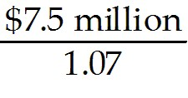 = $7.01 million
Diff: 2
Section: 30.1 Insurance
Skill: Analytical
30.2 Commodity Price Risk

Use the following information to answer the question(s) below.

d'Anconia Copper expects to produce 500 million pounds of copper next year, with production costs of $0.75 per pound. Depending upon the economic conditions over the next year, d'Anconia Copper expects the price of copper next year to be either $1.40, $1.50, or $1.60 per pound, with each outcome being equally likely. d'Anconia Copper expects to sell all of its copper at the going price.

1) If the going price next year is $1.40 per pound, d'Anconia Copper's operating profit next year will be closest to:
A) $325 million
B) $365 million
C) $375 million
D) $425 million
Answer: A
Explanation: A) Operating profit = Sales - COGS = 500 million pounds × $1.40/pound - 500 million pounds × $0.75/pound = $325 million
Diff: 1
Section: 30.2 Commodity Price Risk
Skill: Analytical

2) If the going price next year is $1.60 per pound, d'Anconia Copper's operating profit next year will be closest to:
A) $365 million
B) $375 million
C) $425 million
D) $800 million
Answer: C
Explanation: C) Operating profit = Sales - COGS = 500 million pounds × $1.60/pound - 500 million pounds × $0.75/pound = $425 million
Diff: 1
Section: 30.2 Commodity Price Risk
Skill: Analytical

3) If d'Anconia Copper enters into a contract to supply copper to end users at an average price of $1.48 per pound, then d'Anconia Copper's operating profit next year will be closest to:
A) $325 million
B) $365 million
C) $375 million
D) $425 million
Answer: B
Explanation: B) Operating profit = Sales - COGS = 500 million pounds × $1.48/pound - 500 million pounds × $0.75/pound = $365 million
Diff: 1
Section: 30.2 Commodity Price Risk
Skill: Analytical
4) The risk that the firm will not have, or be able to raise, the cash required to meet the margin calls on its hedges is called:
A) liquidity risk.
B) basis risk.
C) commodity price risk.
D) speculation risk.
Answer: A
Diff: 1
Section: 30.2 Commodity Price Risk
Skill: Definition

5) The risk that arises because the value of the futures contract will not be perfectly correlated with the firm's exposure is called:
A) commodity price risk.
B) basis risk.
C) liquidity risk.
D) speculation risk.
Answer: B
Diff: 1
Section: 30.2 Commodity Price Risk
Skill: Definition

6) Which of the following statements is FALSE?
A) Horizontal integration entails the merger of a firm and its supplier or a firm and its customer.
B) Like insurance, hedging involves contracts or transactions that provide the firm with cash flows that offset its losses from price changes.
C) For many firms, changes in the market prices of the raw materials they use and the goods they produce may be the most important source of risk to their profitability.
D) Because an increase in the price of the commodity raises the firm's costs and the supplier's revenues, these firms can offset their risks by merging.
Answer: A
Explanation: A) Vertical integration entails the merger of a firm and its supplier or a firm and its customer.
Diff: 2
Section: 30.2 Commodity Price Risk
Skill: Conceptual
7) Which of the following statements is FALSE?
A) Firms generally do not possess better information than outside investors regarding the risk of future commodity price changes, nor can they influence that risk through their actions.
B) Cash flows are exchanged on a monthly basis, rather than waiting until the end of the contract, through a procedure called marking to market.
C) The firm may speculate by entering into contracts that do not offset its actual risks.
D) When a firm authorizes managers to trade contracts to hedge, it opens the door to the possibility of speculation.
Answer: B
Explanation: B) Cash flows are exchanged on a daily basis, rather than waiting until the end of the contract, through a procedure called marking to market.
Diff: 2
Section: 30.2 Commodity Price Risk
Skill: Conceptual

8) Which of the following statements regarding futures contracts is FALSE?
A) Both the buyer and the seller can get out of the contract at any time by selling it to a third party at the current market price.
B) Futures prices are not prices that are paid today. Rather, they are prices agreed to today, to be paid in the future.
C) Futures contracts are traded anonymously on an exchange at a publicly observed market price and are generally very illiquid.
D) Traders are required to post collateral, called margin, when buying or selling commodities using futures contracts.
Answer: C
Explanation: C) Futures contracts are traded anonymously on an exchange at a publicly observed market price and are generally very liquid.
Diff: 2
Section: 30.2 Commodity Price Risk
Skill: Conceptual

9) Which of the following statements regarding long-term supply contracts is FALSE?
A) The market value of the contract at any point in time may not be easy to determine, making it difficult to track gains and losses.
B) Long-term supply contracts are designed to eliminate credit risk.
C) Long-term supply contracts insulate the firms from commodity price risk.
D) Long-term supply contracts are bilateral contracts negotiated by a buyer and a seller.
Answer: B
Explanation: B) Long-term supply contracts are designed to eliminate price risk but introduce credit risk.
Diff: 2
Section: 30.2 Commodity Price Risk
Skill: Conceptual
10) Which of the following statements is FALSE?
A) Long-term supply contracts such contracts cannot be entered into anonymously; the buyer and seller know each other's identity. This lack of anonymity may have strategic disadvantages.
B) A futures contract is an agreement to trade an asset on some future date, at a price that is locked in today.
C) An alternative to vertical integration or storage is a long-term supply contract.
D) Long-term supply contracts are unilateral contracts negotiated by a seller.
Answer: D
Explanation: D) Long-term supply contracts are bilateral contracts negotiated by a buyer and a seller.
Diff: 2
Section: 30.2 Commodity Price Risk
Skill: Conceptual

11) What are some of the disadvantages of long-term supply contracts?
Answer: Such contracts have several potential disadvantages. First, they expose each party to the risk that the other party may default and fail to live up to the terms of the contract. Thus, while they insulate the firms from commodity price risk, they expose them to credit risk. Second, such contracts cannot be entered into anonymously; the buyer and seller know each other's identity. This lack of anonymity may have strategic disadvantages. Finally, the market value of the contract at any point in time may not be easy to determine, making it difficult to track gains and losses, and it may be difficult or even impossible to cancel the contract if necessary.
Diff: 2
Section: 30.2 Commodity Price Risk
Skill: Conceptual

12) Your oil refinery will need to buy 250,000 barrels of crude oil in one week and it is worried about crude oil prices. Suppose you go long 250 crude oil futures contracts, each for 1000 barrels of crude oil, at the current futures price of $68 per barrel. Suppose futures prices change each day over the next week as follows:

Day | 1 | 2 | 3 | 4 | 5
Futures Price | 65 | 65.5 | 68 | 67.25 | 70

What is the daily and cumulative mark to market profit or loss (in dollars) that you will have on each of the next five days?
Answer:
Day | 1 | 2 | 3 | 4 | 5
Futures Price | 65 | 65.5 | 68 | 67.25 | 70
Daily mark to market profit/loss (one contract) | -3 | 0.5 | 2.5 | -0.75 | 2.75
Daily mark to market profit/loss (250 contracts) | -750 | 125 | 625 | -187.5 | 687.5
Cumulative mark to market profit/loss (one contract) | -3 | -2.5 | 0 | -0.75 | 2
Cumulative mark to market profit/loss (250 contracts) | -750 | -625 | 0 | -187.5 | 500
Diff: 2
Section: 30.2 Commodity Price Risk
Skill: Analytical
30.3 Exchange Rate Risk

For the following problems, please include a copy of the cumulative standard normal tables.

1) Suppose the current exchange rate is $1.62/£, the interest rate in the united states is 5.25%, the interest rate in the United Kingdom is 4%, and the volatility of the $/£ exchange rate is 18%. Using the Black-Scholes formula, the price of a six-month European call option on the British pound with a strike price of $1.60/£ will be closest to:
A) $0.040/£
B) $0.059/£
C) $0.078/£
D) $0.097/£
Answer: D
Explanation: D) FT = S × 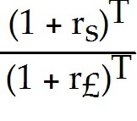 = 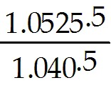 = $1.62 × 1.005992 = 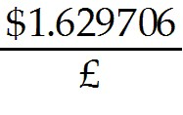
d1 = 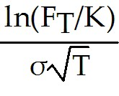 + 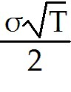 = 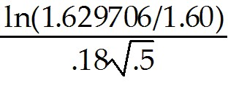 + 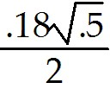 = 0.208172 or 0.21
d2 = d1 - σ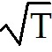 = .208172 - .18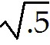 = .080893 or .08
C = 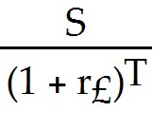N(d1) - 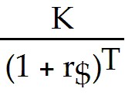N(d2) = 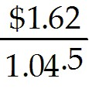 (.5832) - 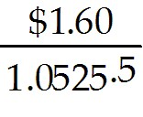(0.5219) = 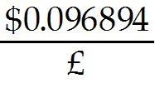
where N(.21) = .5832 and N(.08) = .5319 from the cumulative standard normal tables.
Diff: 3
Section: 30.3 Exchange Rate Risk
Skill: Analytical
2) Suppose the current exchange rate is $1.42/€, the interest rate in the United States is 4.0%, the interest rate in the EU is 6%, and the volatility of the $/€ exchange rate is 20%. Using the Black-Scholes formula, the price of a three-month European call option on the Euro with a strike price of $1.45/€ will be closest to:
A) $0.040/€
B) $0.059/€
C) $0.078/€
D) $0.097/€
Answer: A
Explanation: A) FT = S × = 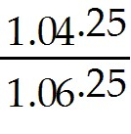 = $1.42 × 0.995249 = 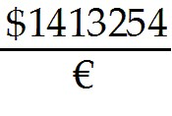
d1 = + = 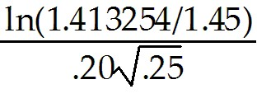 + 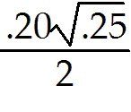 = -0.206687 or -0.21
d2 = d1 - σ = -0.206687 - 20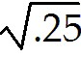 = -0.306687 or -0.31
C = 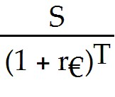N(d1) - N(d2) = 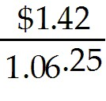 (.4168) - 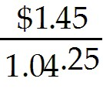(0.3783) = 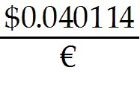
where N(-0.21) = 1 - N(.21) = 1 - .5832 = 0.4168 and N(-0.31) = 1 - N(0.31) = .3783 from the cumulative standard normal tables.
Diff: 3
Section: 30.3 Exchange Rate Risk
Skill: Analytical

3) Like most foreign exchange rates, the dollar/euro rate is a floating rate, which means it changes constantly depending on the quantity supplied and demanded for each currency in the market. The supply and demand for each currency is driven directly by all of the following factors EXCEPT:
A) relative inflation.
B) firms trading goods.
C) investors trading securities.
D) the actions of central banks in each country.
Answer: A
Diff: 1
Section: 30.3 Exchange Rate Risk
Skill: Conceptual

4) A currency forward contract specifies all of the following EXCEPT:
A) the amount of currency to exchange.
B) the spot exchange rate.
C) the delivery date on which the exchange will take place.
D) the currencies to be exchanged.
Answer: B
Diff: 1
Section: 30.3 Exchange Rate Risk
Skill: Conceptual
5) The cash-and-carry strategy consists of all of the following simultaneous trades EXCEPT:
A) borrow euros today using a one-year loan with the interest rate r€.
B) exchange the euros for dollars today at the spot exchange rate S $/€.
C) purchase a forward contract to convert $ to €.
D) invest the dollars today for one year at the interest rate r$.
Answer: C
Diff: 2
Section: 30.3 Exchange Rate Risk
Skill: Conceptual

6) Which of the following statements is FALSE?
A) The most common method firms use to reduce the risk that results from changes in exchange rates is to hedge the transaction using currency forward contracts.
B) Fluctuating exchanges rates cause a problem known as the importer—exporter dilemma for firms doing business in international markets.
C) Exchange rate risk naturally arises whenever transacting parties use different currencies: Both of the parties will be at risk if exchange rates fluctuate.
D) Because the supply and demand for currencies varies with global economic conditions, exchange rates are volatile.
Answer: C
Explanation: C) Exchange rate risk naturally arises whenever transacting parties use different currencies: One of the parties will be at risk if exchange rates fluctuate.
Diff: 2
Section: 30.3 Exchange Rate Risk
Skill: Conceptual

7) Which of the following statements is FALSE?
A) The covered interest parity equation states that the difference between the forward and spot exchange rates is related to the interest rate differential between the currencies.
B) By entering into a currency forward contract, a firm can lock in an exchange rate in advance and reduce or eliminate its exposure to fluctuations in a currency’s value.
C) When the interest rate differs across countries, investors have an incentive to borrow in the low-interest rate currency and invest in the high interest rate currency.
D) A currency forward is usually written between two firms, and it fixes a currency exchange rate for a transaction that will occur at a future date.
Answer: D
Explanation: D) A currency forward is usually written between a firm and a bank, and it fixes a currency exchange rate for a transaction that will occur at a future date.
Diff: 2
Section: 30.3 Exchange Rate Risk
Skill: Conceptual
8) Which of the following statements is FALSE?
A) Currency options allow firms to lock in a future exchange rate; currency forward contracts allow firms to insure themselves against the exchange rate moving beyond a certain level.
B) Generally speaking, cash-and-carry strategies are used primarily by large banks, which can borrow easily and face low transaction costs.
C) Currency options, like the stock options, give the holder the right–but not the obligation–to exchange currency at a given exchange rate.
D) Many managers want the firm to benefit if the exchange rate moves in their favor, rather than being stuck paying an above-market rate.
Answer: A
Explanation: A) Currency forward contracts allow firms to lock in a future exchange rate; currency options allow firms to insure themselves against the exchange rate moving beyond a certain level.
Diff: 2
Section: 30.3 Exchange Rate Risk
Skill: Conceptual

9) Which of the following statements regarding currency options is FALSE?
A) Firms often prefer forward contracts to currency options if the transaction they are hedging might not take place.
B) Currency options are another method that firms commonly use to manage exchange rate risk. Currency options, like the stock options, give the holder the right–but not the obligation–to exchange currency at a given exchange rate.
C) Currency forward contracts allow firms to lock in a future exchange rate; currency options allow firms to insure themselves against the exchange rate moving beyond a certain level.
D) Many managers want the firm to benefit if the exchange rate moves in their favor, rather than being stuck paying an above-market rate.
Answer: A
Explanation: A) Firms often prefer options to forward contracts if the transaction they are hedging might not take place.
Diff: 2
Section: 30.3 Exchange Rate Risk
Skill: Conceptual

10) In December 2005, the spot exchange rate for the British Pound was $1.7188/£. Suppose that at the same time the on-year interest rate in the United States was 4.85% and the one-year interest rate in Great Britain was 3.15%. Based on these rates, what forward exchange rate is consistent with no arbitrage.
Answer: F = S × 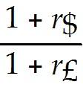 = $1.7188 × 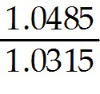 = $1.7471/£
Diff: 2
Section: 30.3 Exchange Rate Risk
Skill: Analytical
11) In December 2005, the spot exchange rate for the British Pound was $1.7188/£ and the one-year forward rate was $1.8675/£. Suppose that at the same time Luther Industries entered into a contract to purchase goods with a price of £375,000 to be delivered in one year. Simultaneously Luther entered into a one-year forward contract to purchase £375,000. What is the amount of the payment in U.S. dollars that Luther Industries will have to make in one year to pay for their goods?
Answer: Since Luther entered into a forward contract, the exchange rate is fixed at the one-year forward rate of $1.8675/£. Therefore Luther Industries will have to pay £375,000 × $1.8675/£ = $700,312.50.
Diff: 1
Section: 30.3 Exchange Rate Risk
Skill: Analytical

30.4 Interest Rate Risk

Use the following information to answer the question(s) below.

You are a risk manager for Security First Trust Savings and Loan (SFTSL). SFTSL's balance sheet is as follows (in millions of dollars):

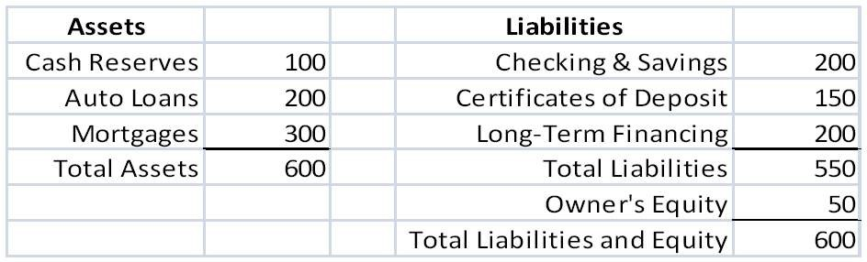

The duration of the auto loans is three years and the duration of the mortgages is eight years. Both cash reserves and checking and savings have zero duration. The CDs have a duration of two years and the long-term financing has a ten year duration.

1) The duration of SFTSL's equity is closest to:
A) 6 years
B) 8 years
C) 10 years
D) 14 years
Answer: D
Explanation: D) Dassets = 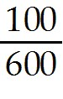 × 0 (cash) + 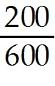 × 3 (auto) + 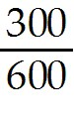 × 8 (mortgage) = 5 years
Dliabilities = 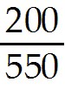 × 0 (checking) + 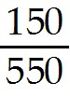 × 2 (CDs) + × 10 (Long Term) = 4.181818 years
Dequity = Dassets-liabilities = 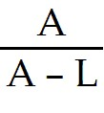DA - 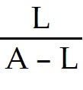DL
= 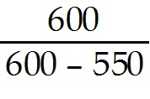(5) - 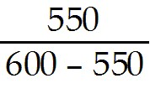(4.181818) = 14.00 years
Diff: 2
Section: 30.4 Interest Rate Risk
Skill: Analytical
2) Because of a new program called Kash for Klunkers, SFTSL experiences a rash of auto loan prepayments, reducing the size of the auto loan portfolio from $200 million to $100 million and increasing the cash reserves to $200 million. After these prepayments, the duration of SFTSL's equity is closest to:
A) 6 years
B) 8 years
C) 10 years
D) 14 years
Answer: B
Explanation: B) Dassets = × 0 (cash) + × 3 (auto) + × 8 (mortgage) = 4.5 years
Dliabilities = × 0 (checking) + × 2 (CDs) + × 10 (Long Term) = 4.181818 years
Dequity = Dassets-liabilities = DA - DL
= (4.5) - (4.181818) = 8.00 years
Diff: 2
Section: 30.4 Interest Rate Risk
Skill: Analytical

3) If interest rates are currently 5%, but fall to 4%, your estimate of the approximate change in SFTSL equity is closest to:
A) 8% decrease
B) 12% decrease
C) 8% increase
D) 14% increase
Answer: D
Explanation: D) Dassets = × 0 (cash) + × 3 (auto) + × 8 (mortgage) = 5 years
Dliabilities = × 0 (checking) + × 2 (CDs) + × 10 (Long Term) = 4.181818 years
Dequity = Dassets-liabilities = DA - DL
= (5) - (4.181818) = 14.00 years
Therefore, if interest rates fall by 1%, the value of SFTSL's equity will increase by about 14%.
Diff: 3
Section: 30.4 Interest Rate Risk
Skill: Analytical
4) Which of the following statements is FALSE?
A) We can measure a firm's sensitivity to interest rates by computing the duration of its balance sheet.
B) Just as the interest rate sensitivity of a single cash flow increases with its maturity, the interest rate sensitivity of a stream of cash flows increases with its duration.
C) By restructuring the balance sheet to increase its duration, we can hedge the firm's interest rate risk.
D) A firm's market capitalization is determined by the difference in the market value of its assets and its liabilities.
Answer: C
Explanation: C) By restructuring the balance sheet to reduce its duration, we can hedge the firm's interest rate risk.
Diff: 1
Section: 30.4 Interest Rate Risk
Skill: Conceptual

5) Which of the following statements is FALSE?
A) As interest rates change, the market values of the securities and cash flows in the portfolio change as well, which in turn alters the weights used when computing the duration as the value-weighted average maturity.
B) The duration of a portfolio of investments is the simple average of the durations of each investment in the portfolio.
C) Adjusting a portfolio to make its duration neutral is sometimes referred to as immunizing the portfolio, a term that indicates it is being protected against interest rate changes.
D) When the durations of a firm's assets and liabilities are significantly different, the firm has a duration mismatch.
Answer: B
Explanation: B) The duration of a portfolio of investments is the value-weighted average of the durations of each investment in the portfolio.
Diff: 2
Section: 30.4 Interest Rate Risk
Skill: Conceptual

6) Which of the following statements is FALSE?
A) Interest rate swaps are an alternative means of modifying the firm’s interest rate risk exposure without buying or selling assets.
B) A portfolio with a negative duration is called a duration-neutral portfolio or an immunized portfolio, which means that for small interest rate fluctuations, the value of equity should remain unchanged.
C) Maintaining a duration-neutral portfolio will require constant adjustment as interest rates change.
D) A duration-neutral portfolio is only protected against interest rate changes that affect all yields identically.
Answer: B
Explanation: B) A portfolio with a zero duration is called a duration-neutral portfolio or an immunized portfolio, which means that for small interest rate fluctuations, the value of equity should remain unchanged.
Diff: 2
Section: 30.4 Interest Rate Risk
Skill: Conceptual
7) Which of the following statements is FALSE?
A) The swap contract—like forward and futures contracts—is typically structured as a "zero-cost" security.
B) An interest rate swap is a contract entered into with a bank, much like a forward contract, in which the firm and the bank agree to exchange the coupons from two different types of loans.
C) In a standard interest rate swap, one party agrees to pay coupons based on a fixed interest rate in exchange for receiving coupons based on the prevailing market interest rate during each coupon period.
D) If short-term interest rates were to fall while long-term rates remained stable, then short-term securities would fall in value relative to long-term securities, despite their shorter duration.
Answer: D
Explanation: D) If short-term interest rates were to rise while long-term rates remained stable, then short-term securities would fall in value relative to long-term securities, despite their shorter duration.
Diff: 2
Section: 30.4 Interest Rate Risk
Skill: Conceptual

8) Which of the following statements is FALSE?
A) Corporations use interest rate swaps routinely to alter their exposure to interest rate fluctuations.
Firms can use interest rate swaps with duration-hedging strategies.
B) The value of a swap, while initially zero, will fluctuate over time as interest rates change.
C) An interest rate that adjusts to current market conditions is called a floating rate.
D) When interest rates rise, the swap's value will rise for the party receiving the fixed rate; conversely, it will fall for the party paying the fixed rate.
Answer: D
Explanation: D) When interest rates rise, the swap's value will fall for the party receiving the fixed rate; conversely, it will rise for the party paying the fixed rate.
Diff: 2
Section: 30.4 Interest Rate Risk
Skill: Conceptual

9) What is the duration of a five-year zero-coupon bond?
A) 2.5 Years
B) 1 Year
C) 5 Years
D) 0 Years
Answer: C
Explanation: C) For a zero-coupon bond, there is only a single cash flow. Thus PV(CF5) = P and the the duration is qual to the bond's maturity of five years.
Diff: 1
Section: 30.4 Interest Rate Risk
Skill: Analytical
10) The duration of a five-year bond with 8% annual coupons trading at par is closest to:
A) 2.5 Years
B) 4.3 Years
C) 5.0 Years
D) 6.2 Years
Answer: B
Explanation: B) Duration = 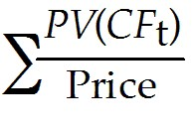 × t

t (years) | CFt | PV(CFt) | PV(CFt)/P | [PV(CFt)/P] × t
1 | 8 | 7.4074 | 0.0741 | 0.0741
2 | 8 | 6.8587 | 0.0686 | 0.1372
3 | 8 | 6.3507 | 0.0635 | 0.1905
4 | 8 | 5.8802 | 0.0588 | 0.2352
5 | 108 | 73.5030 | 0.7350 | 3.6751
 | Bond Price= | 100 | 100.00%
 |  |  | Duration = | 4.3121 Years
Diff: 3
Section: 30.4 Interest Rate Risk
Skill: Analytical

11) The Century 22 fund has invested in a portfolio of mortgaged backed securities that has a current market value of $245 million. The duration of this portfolio of mortgaged back securities is 14.7 years. The fund has borrowed to purchase these securities, and the current value of its liabilities (i.e., the current value of the bonds Century 22 has issued) is $160 million. The duration of these liabilities is 5.4 years. What is the initial duration of the equity for the Century 22 fund?
Answer: DE = DA - L = 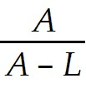DA - 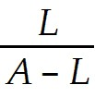DL = 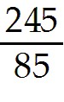(14.7) - 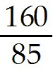(5.4) = 32.21 years
Diff: 2
Section: 30.4 Interest Rate Risk
Skill: Analytical

12) Luther Industries needs to borrow $50 million in cash. Currently long-term AAA rates are 9%. Luther can borrow at 9.75% given its current credit rating. Luther is expecting interest rates to fall over the next few years, so it would prefer to borrow at the short-term rates and refinance after rates have dropped. Luther management is afraid, however, that its credit rating may fall which could greatly increase the spread the firm must pay on new borrowings. How can Luther benefit from the expected decline in future interest rates without exposure to the risk of the potential future changes to its credit ratings bring?
Answer: Luther can borrow at the long term rate of 9.75% and then enter into a swap arrangement where it receives a fixed rate of 9% and pays the short-term rate. In this way Luther locks in its current credit spread of 0.75% but gets the benefit of lower rates if the rates decline.
Diff: 2
Section: 30.4 Interest Rate Risk
Skill: Analytical

